**Simultaneous Confidence Interval Methods for Analytical Similarity Assessment**

Jiayin Zheng1, Donglei Yin2, Mengdie Yuan3, Shein-Chung Chow3

1Biostatistics Program, Public Health Sciences, Fred Hutchinson Cancer Research Center,

1100 Fairview Ave N, Seattle, WA 98109, USA.

2Department of Applied Mathematics and Statistics, Stony Brook University,

100 Nicolls Road, Stony Brook, NY 11794, USA.

3Office of Biostatistics, Center for Drug Evaluation and Research,

U.S. Food and Drug Administration,

10903 New Hampshire Avenue, Silver Spring, MD 20993, USA.

**Abstract**

Assessment of biosimilarity between a proposed biosimilar drug product (test product) and an innovative biological drug product (reference product) is usually performed when the innovative biological drug product is going off patent protection. However, when there were multiple references, e.g., a US-licensed reference product and a EU-approved reference product of the same product, besides the biosimilarity between the reference and the test, extra evidence in terms of the biosimilarity between the two references drug should also be provided. The method of pairwise comparisons has been widely used, but recently criticized, due to its use of different EAC (equivalence acceptance criterion) based on the different reference products for the three comparisons, the accuracy and reliability of each pairwise comparison since each comparison does not fully utilize all data collected from the three treatment groups, as well as the justification of bridging PK and/or clinical data. To avoid issues discussed above, we proposed one alternative simultaneous confidence approach based on fiducial inference theory. Scenarios with and without the assumption of equal variance between the three populations were discussed. For each scenario, three versions of simultaneous confidence methods were proposed based on the different assumptions of population variance, and within each version, two types of simultaneous confidence interval were suggested. Cases where pairwise comparison fails but the simultaneous confidence approach passed were illustrated. For the scenario with equal variance assumption, extensive simulation studies were conducted to further investigate the performance of the simultaneous confidence approach.

**Keywords:** biosimilarity; multiple reference; simultaneous confidence interval; fiducial inference

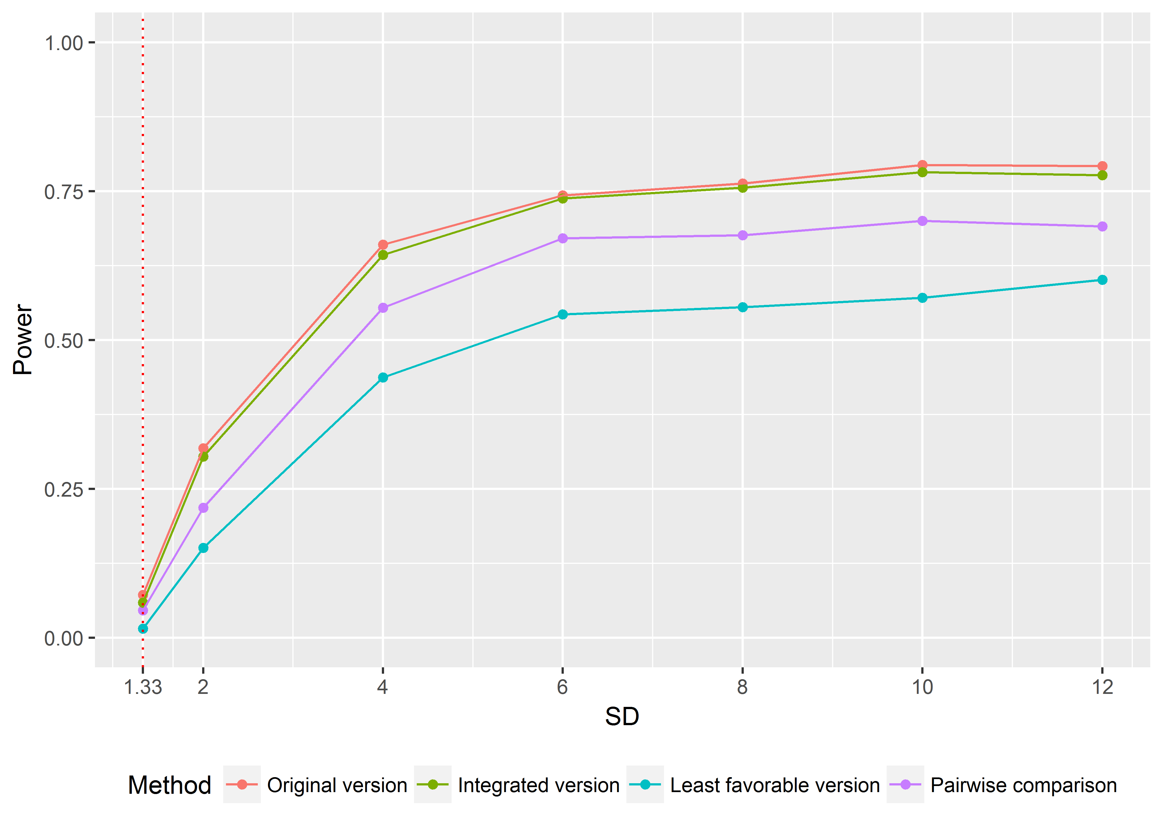

**Figure 1. Simulation performance of different methods (equal variance scenario).** The purple line represents the pairwise comparison, and the rest three lines represents the three versions of simultaneous confidence interval approach (original, integrated and least favorable version). The x-axis represents the sample standard deviation which takes values from 1.33 to 12, where the red-dotted line (SD=1.33) is the rejection margin under EAC. The y-axis represents the empirical power based on 1000 replications. Sample means for the two reference drugs and the test drug were set to be: $μ_{R_{1}}=99, μ_{R_{2}}=101, μ_{T}=100.$ Sample size $n_{R_{1}}= n_{R_{2}}=n_{T}=10$. Significant level was set to be 0.05. The figure indicates that the original (orange line) and integrated (green) version of simultaneous confidence interval approach have significantly larger power than the pairwise comparison (purple), and the superiority maintains as the standard deviance varies. While the least favorable version (blue) performs the worst among the four methods.